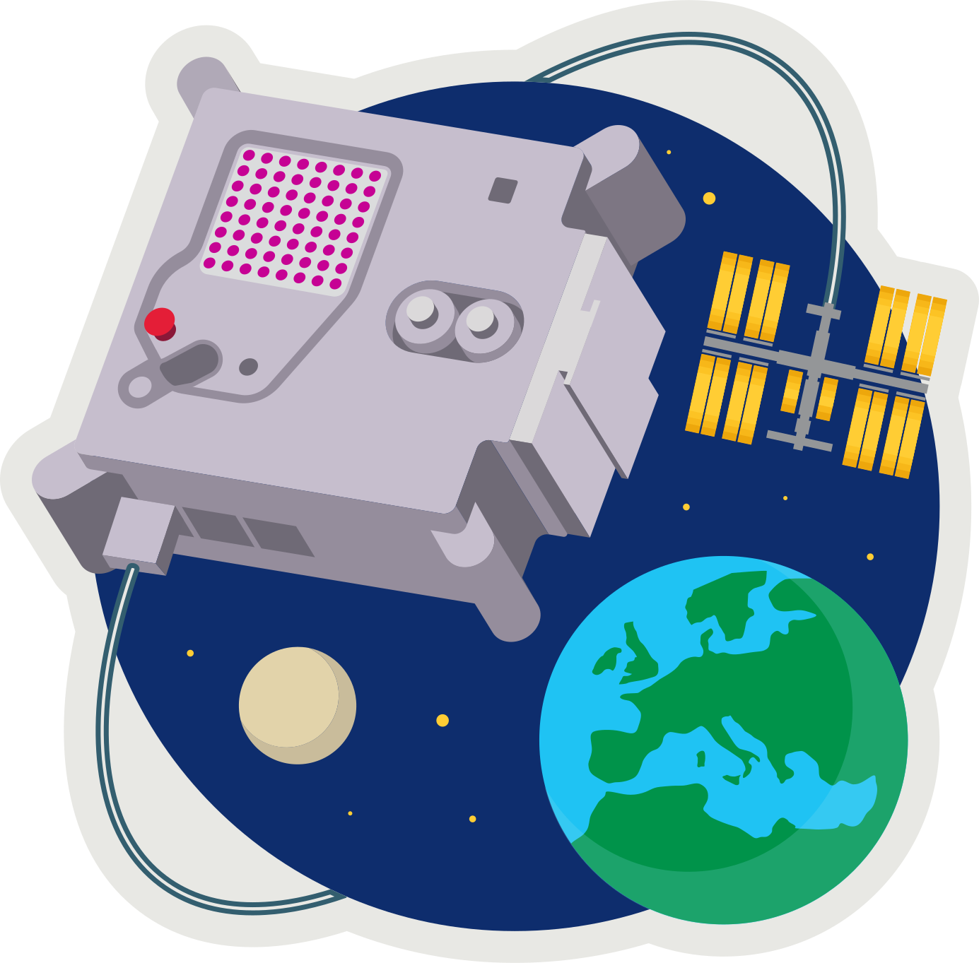
ASTRO PI MISSION ZERO
Part 3: Colour Sensor

Send a personalised image to the astronauts on the International Space Station!

Last week you created 8x8 pixel-art (8 pixels high by 8 pixels wide)
Pixels are picture elements.

- Open pixilart.com (we can all use the same login CodeClub67)


- Click on the profile avatar at the top-right of the window
- Select My Gallery
- Click on your first image (if you want to change it click edit)
- In the panel on the right scroll down to Details
- Click Download Original to download a .png (ping) image.
- Save this in your downloads folder.

- MISSION ZERO grid
- Open https://codeclub67.github.io/astro-pi
- Choose the .png file in downloads
- Complete the first mission grid on the sheet.
- Write your name on the back.

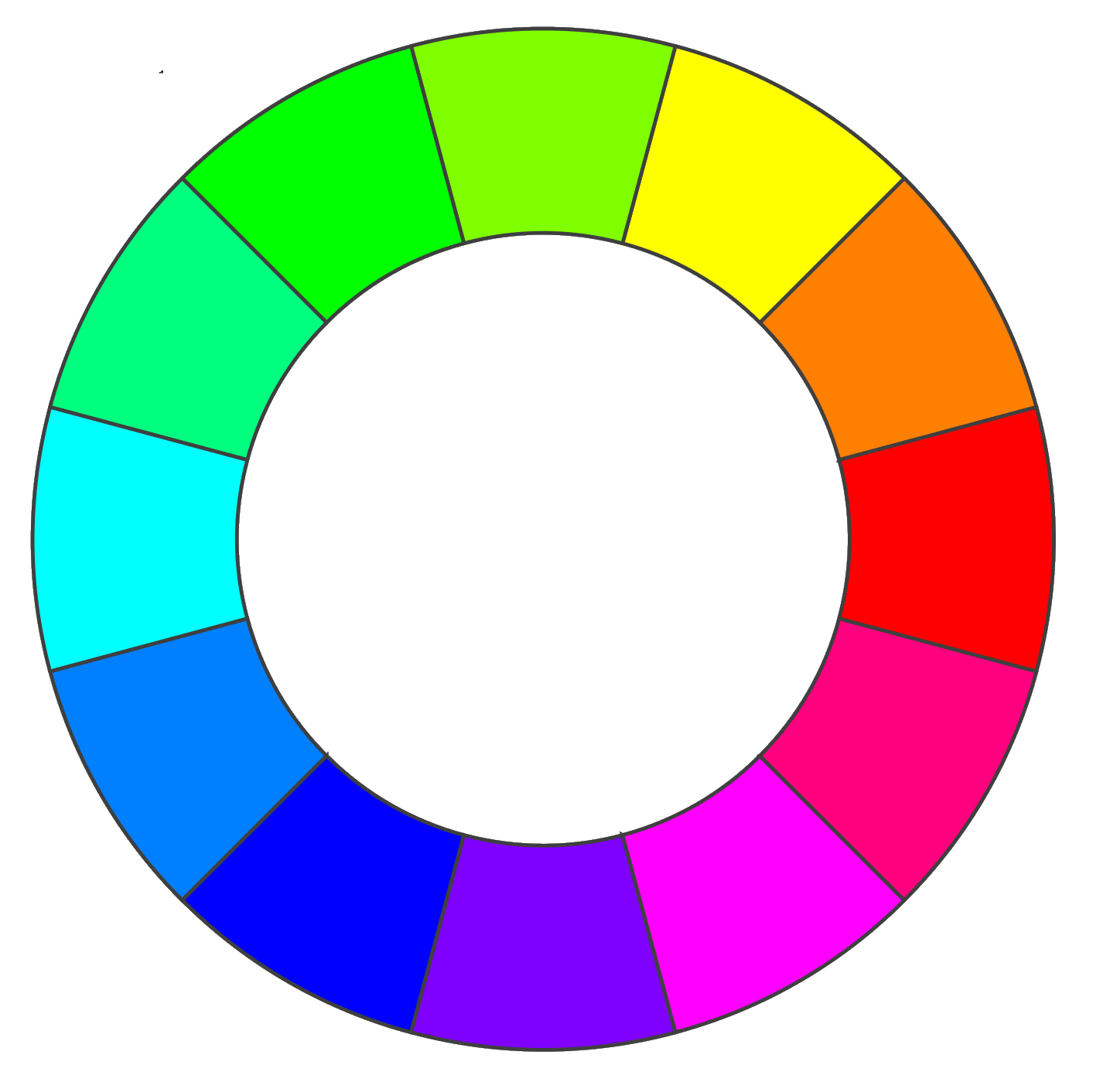
Your first mission is to change your image using a sensor reading. We can simulate this in Scratch.

Use a sensor to change image colours.

Colours can be placed on a colour wheel. Any colour can be shifted clockwise around the wheel using the Scratch colour effect with the shift value.

The wheel is 200 units around, so a value of 100 will shift any colour to the opposite side.

MISSION ZERO – Scratch Simulation
- Login to scratch.mit.edu
- Create a new Scratch project
- Upload a new sprite using the .png image in downloads.
- It’s very small – only 8x8. Adjust the size to 2000%
- Simulate a sensor by making a new variable, called temperature.
- Make sure the variable is ticked so it’s shown on-screen.
- Right-click on the on-screen variable to make it a slider.
- Right-click on the on-screen variable to change slider range
Set the maximum value to 200 (the circumference of the colour wheel), OK
- Add this code to set the colour effect according to the temperature.
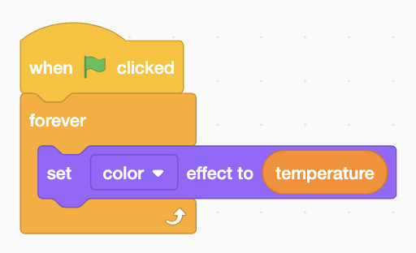
- Run the code and change the temperature.

Try a temperature of 100, does it shift the colour to the opposite side of the colour wheel?

A sensor value of 200 should take the colour all the way round the colour wheel back to where it started. What happens?

Astro-pi
Your tutor will show you how to do the same thing on the Astro-pi.
- Open Astro-pi Mission Zero:
https://missions.astro-pi.org/mz/code_submissions/new
- Paste in and demo the example sensor code from:
https://codeclub67.github.io/astro-pi/temperature_sensor.py
- Download a Pixilart gallery image and use the Mission Zero image encoder tool to generate the image and paste this into the Python code, and indent as necessary:
https://codeclub67.github.io/astro-pi/encoder.html
- Run the code and vary the temperature
- The code also uses the colour sensor to clear the screen at the end.
- Enter classroom code and team name and save the work
(no need to submit yet)

astro-pi.org

